**Investor Q and A Report**

1. **Does the Showcase have contracts with the Hollywood studios?  This is a critical question given the 3.1 mile issue.**

In actuality competitive zones are established by the request of an exhibitor.

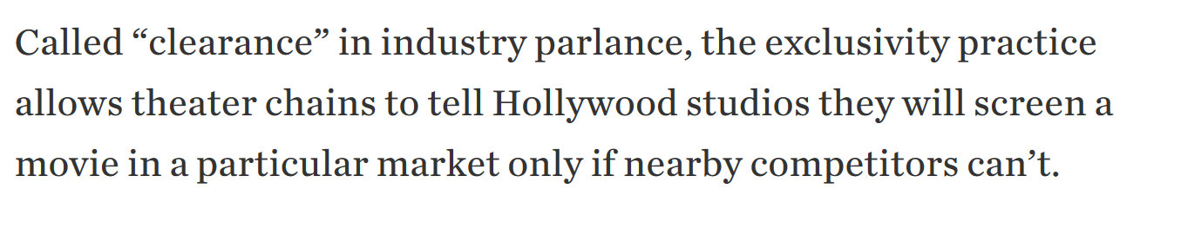In these zones a period of ‘Clearance’ is recognized.

However, there usually aren’t written contracts between studios and theaters. These are usually unofficial agreements. In fact, now more than ever, Hollywood is wary about putting these practices in writing because of the following:

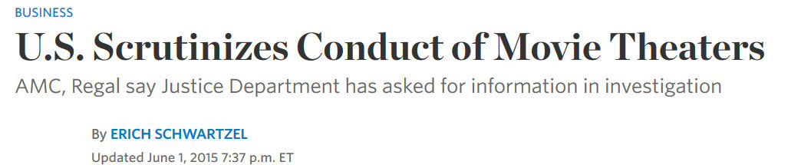

Contacts with the major studios stated they will continue to enforce these zones to protect the fidelity of their revenue sources.

Hollywood wants to reward theaters that generate more revenue and re-invest in their facilities. Recent industry surveys have shown a direct link between theater owner investment, increased attendance and movie revenue:

Studios reward Clearance to protect higher Average Ticket Prices in these upgraded facilities. Movie distributors understand that consumers will always go for the facility with the lowest price for the same product. This in turn undercuts their ROI. Hence studios want market areas with high ATP preserved.

* All of Galleria Adult tickets are $10.
* Showcase with its diverse offering will have an ATP of over $12.

Hollywood wants that extra $2 premium at higher occupancy rates.

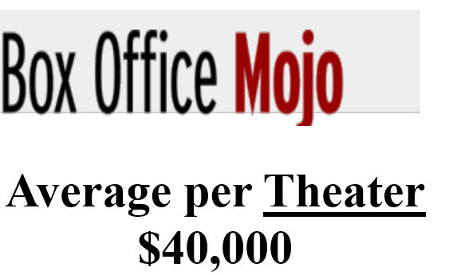

Let’s use the current conditions in the Bahamian market as it stands to illustrate. The top movie globally for 2015 was Fast and Furious 7. The typical US cinema in its first 3 weeks averaged:

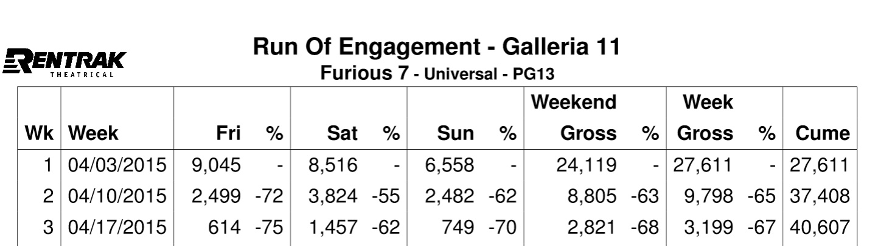How did Galleria Cinema 11 at the Mall at Marathon compare?

Their results fall in line with the norm in the US market.

Now let’s compare the premium brands of IMAX and 4DX.

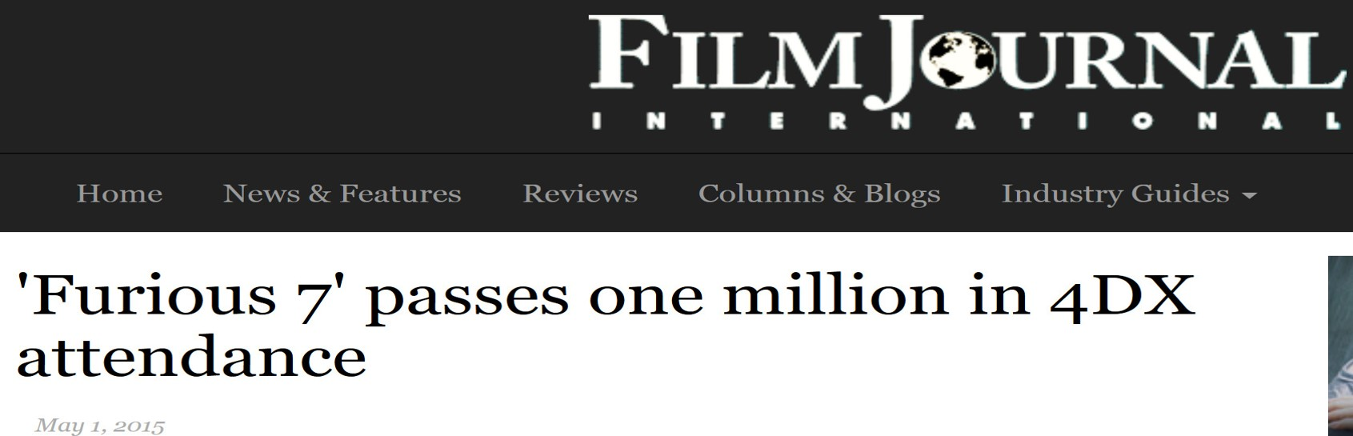

Results:

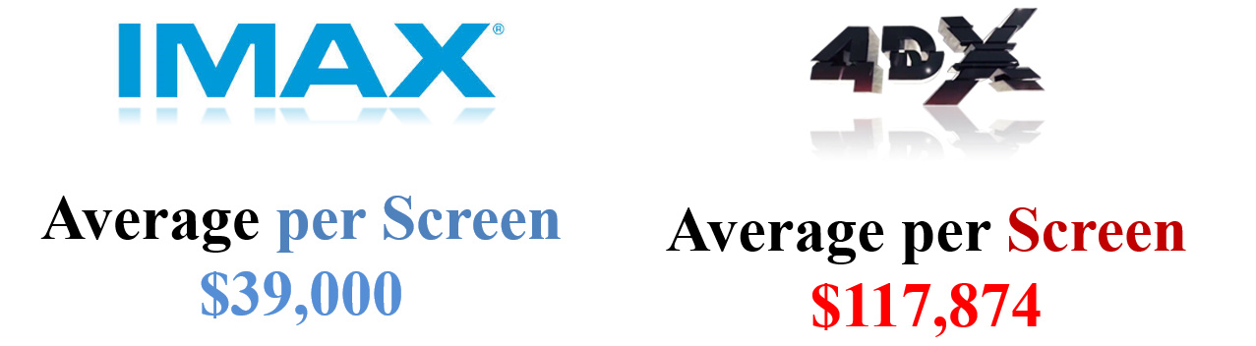

**Note:**

When analyzing these results, it is important to recognize that one is comparing revenue from a single 4DX screen or a single IMAX screenvs the revenue from **AN ENTIRE CINEPLEX with multiple screens**. In the case of Galleria; its revenue from 11 screens vs one 4DX screen.

One 4DX screen more than doubles the revenue from an entire average US facility on a per movie basis. An IMAX screen merely matches a rival facility’s box office on a given movie.

**Hollywood studios will protect this level of revenue generation at all cost.**

1. **Details on the sponsorships?**

The Sponsorship program is going very well for the Showcase with IMAX. In fact the Atavus Group management team has had to slow down the process to take full advantage of developing business conditions.

Creating a Bidding War

C:\Users\Lavern\AppData\Local\Microsoft\Windows\INetCache\Content.Word\Fullscreen capture 692015 32212 PM.JPGThe Government of the Bahamas has recently announced the end of the local telecommunication giant’s cellular monopoly on the market. The Bahamas Telecommunications Corporation (BTC) is in for a fight.



Traditionally, banks and media companies have been perfect partner for IMAX branding.

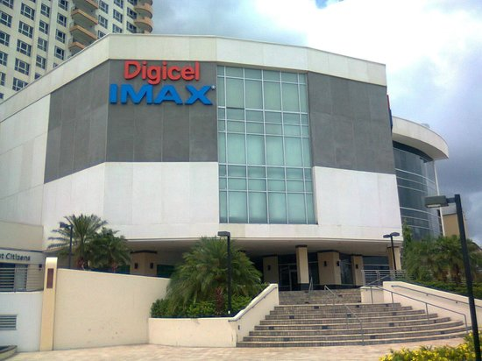

Hence this news could not have come at a more opportune time for Atavus Group.

New Bidders to Enter the Cellular Market

The major players to enter the cellular market are known global entities that have embraced sponsorship.



The stakes are very high for BTC.



Hence BTC have started a massive spending campaign to lock down all possible marketing opportunities before liberalization.

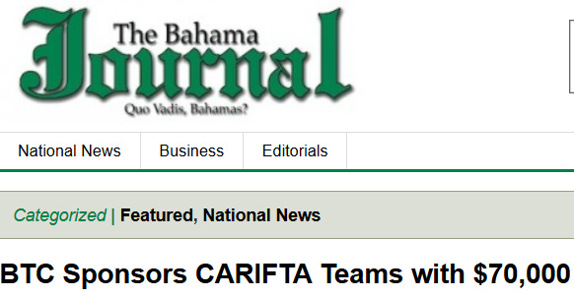

Building on existing Relationships

The Atavus Group has already begun negotiations with BTC and with Cable Bahamas. In fact, BTC and Atavus have already signed a Letter of Offer formally acknowledging common interest in each other from 2014.

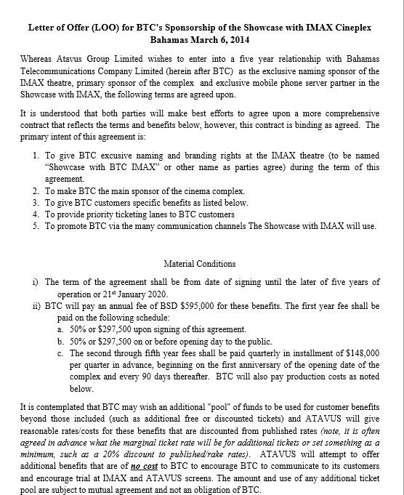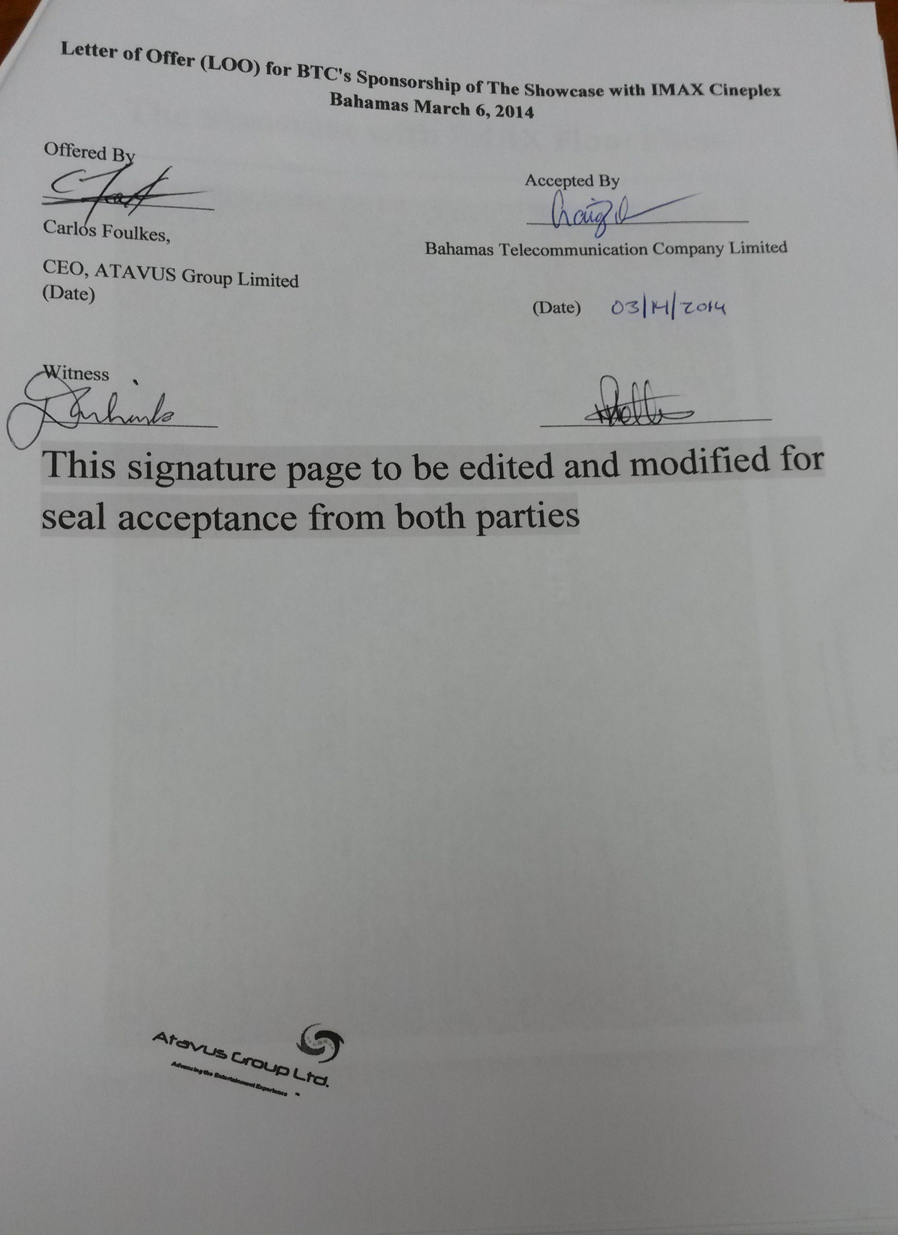

The sum discussed was $595,000 annually for five (5) years. This was even before Atavus Group had secured an actual site for the Showcase with IMAX.

However due to the increased exposure of the new location and the expansion of the business model to reach more of the desired clientele, BTC and Atavus have begun renegotiations.

Besides media-based companies, Atavus met with Pepsi’s regional representatives about possible naming rights of the facility.

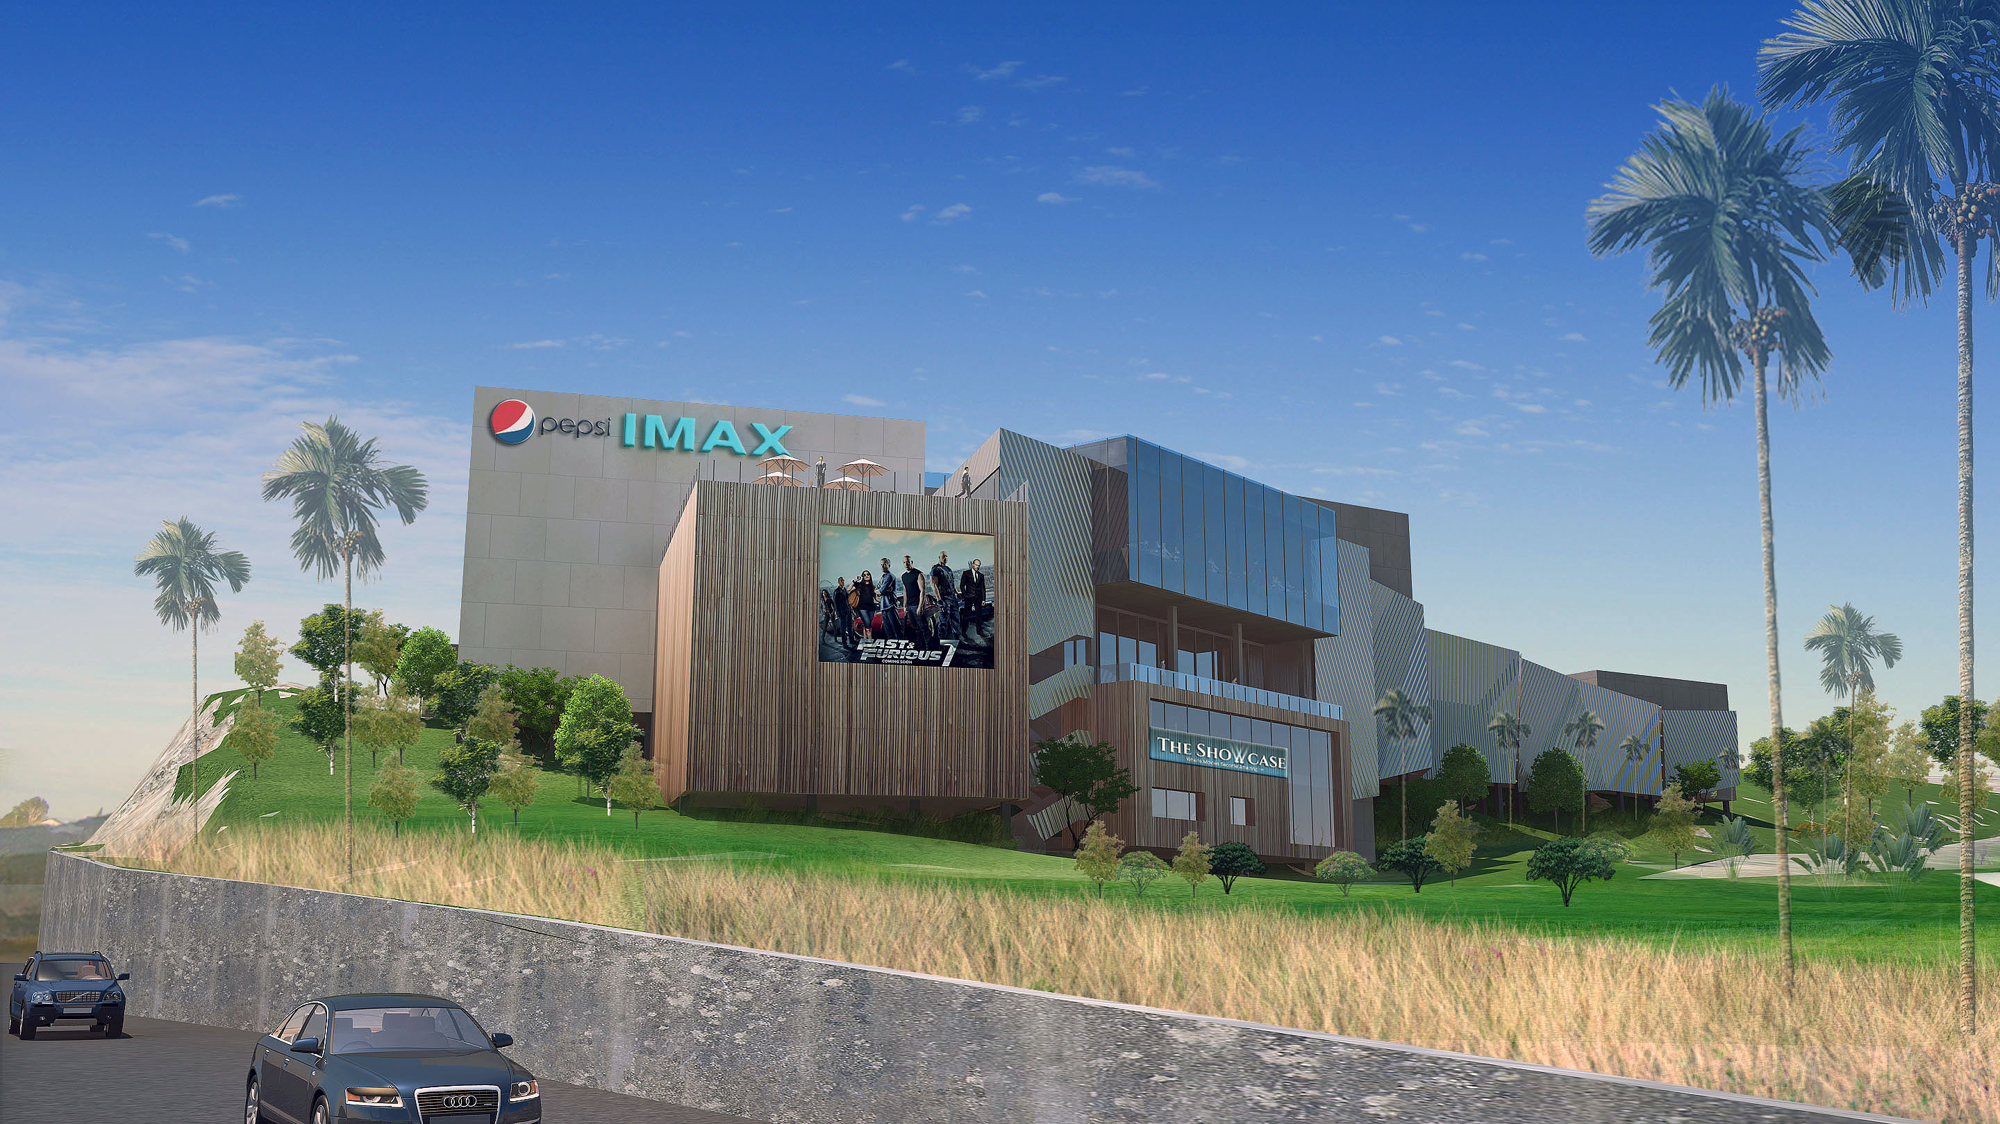

Pepsi previously had a factory in the Bahamas which closed in 2008. At that time, Pepsi had over 30 % market share. Currently, they have less than 6%. Pepsi now wants to re-enter the Bahamian market as a major player in beverage sales.

To do this, Pepsi is looking for branding partners to maximize its Bahamian exposure. The launch of the Showcase with IMAX is a familiar promotional tool for Pepsi, having sponsored multiple IMAX theaters globally.

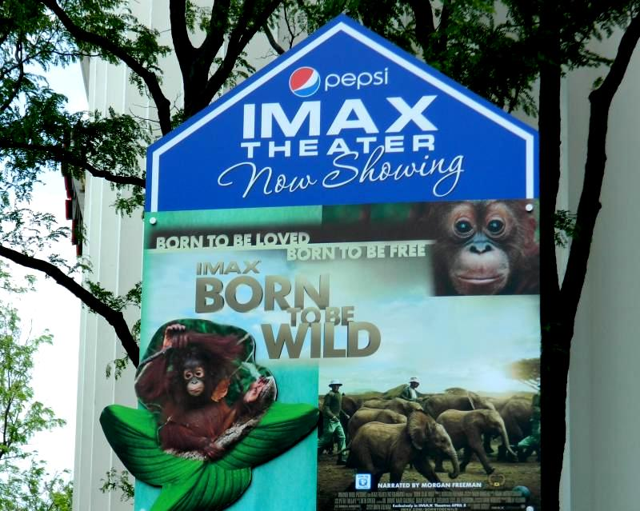

This potential relationship may also have the added benefit of reducing COGS for concessions.

The new starting term is $859,000 annually over five years.

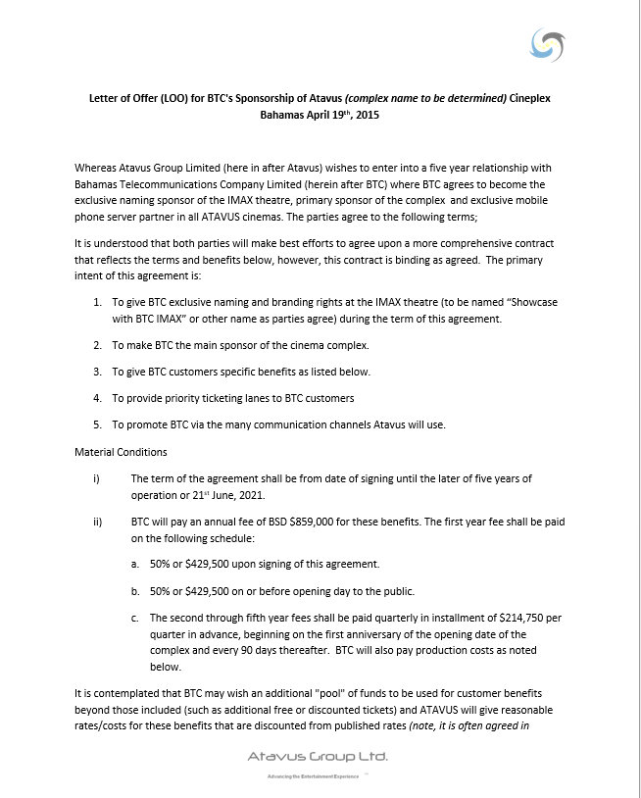

This represents more than 71% of the total sponsorship revenue.

Other sponsorship initiatives have already yielded great interest in the Bahamas were the concept of sponsorship is new.

IMAX’s Education program is garnering a great deal of interest from Bahamian Insurers.

There has never been a private educational program of this magnitude with international appeal.

Companies view the potential of the untapped student customer base as quite attractive.

This is merely a glimpse into the sponsorship program. Spearheaded by Jim Patterson, Global Leader in IMAX and 4DX theater sponsorship, a vigorous program is being custom crafted for each client. Atavus Group is confident the Sponsorship will surpass its projections before theater launch.

1. **Competitive analysis – why would the existing theater group not reinvest in its current locations?**

**Reason 1 for Lack of Re-investment:**

***Galleria’s track record has shown that only external industry conditions force them to re-invest. When they do make changes, management uses cheap, inefficient solutions that alienate their customer base and hurt their bottom line.***

Example 1: 3D adoption in the Bahamas and its subsequent failure

Galleria adopted 3D movies in 2010, almost two years after 3D became standard. Financially this was a poor decision when considering what movie product was dominating the landscape. Avatar in 3D made more money for theater owners than any movie in history.

Why 3D failed in the Bahamas miserably:

A proper 3D presentation requires four (4) components:

* 3D glasses
* A silver screen to decrease light lose
* Updated projectors
* A 3D module that can adjust the image as it leaves the projector

Besides the cheap 3D glasses, Galleria bought the 3D modules for their projectors. They continued to use their old screens and outdated projectors.

Results:

* Patrons complained of headache due to the poor presentation
* Movies were out of focus or too dark to view

Atavus group conducted focus groups on 3D movie goers in 2013.

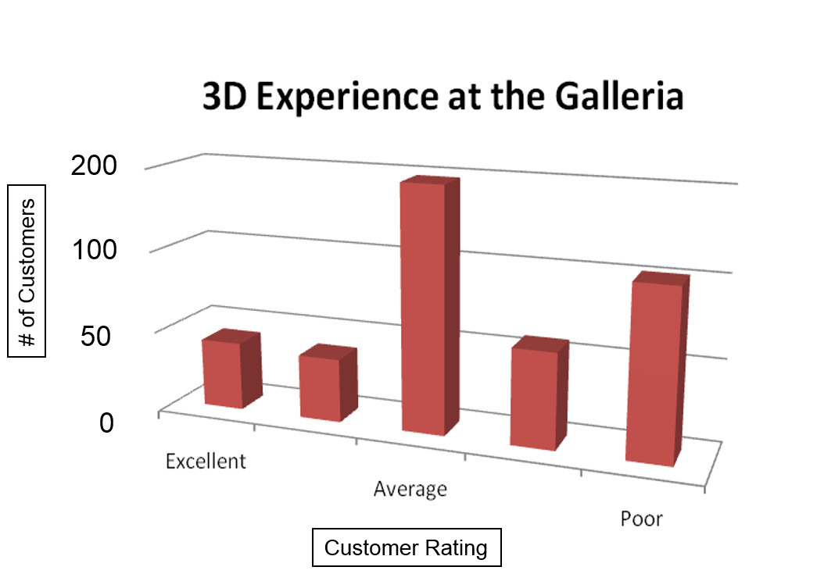

Less than 17% of respondent had a positive 3D experience at Galleria.

Conclusion:

By mid-2013, less than three years after 3D was introduced to the Bahamas, Galleria Cinemas no longer showed 3D movies.

Example 2: Late Adoption of Digital technology

The Cinema Industry began switching from film-based projectors to digital projectors. Along with this change came an accompanying upgrade of sound systems.

Some of the Benefits of Digital:

* *Reduced shipping cost by 1000%:*

Film reels could weigh up to 500lb vs Flash drives with movies from studios could fit in the palm of your hand

* *Ad Revenue in the cinema increased 54% with digital projectors:*

Exhibitors could now easily add advertisements before movies at a fraction of the cost of analog projectors

* *Virtual Print Fees for early adaptor:*

**Virtual Print Fee** (VPF) is the name given to a subsidy paid by a [film distributor](http://en.wikipedia.org/wiki/Film_distributor) towards the purchase of [digital cinema](http://en.wikipedia.org/wiki/Digital_cinema) projection equipment for use by a [film exhibitor](http://en.wikipedia.org/wiki/Film_exhibitor) in the presentation of movies. It is intended to primarily assist in the **replacement of film projectors**, and not assist in the purchase of new projection equipment for new construction.

Hollywood set a deadline for all theaters to switch from film (Celluloid) to digital. After December 2013, theater owners that did not convert would no long receive the latest movies.

With all of these major financial benefits and more in place, when did Galleria Cinemas switch?

Galleria Cinema actually waited until **ONE MONTH** before the deadline to convert.

As always Galleria only did the minimum. Even though digital projectors were switched, the 16 year old screens and outdated sound system remain.

**Reason 2 for Lack of Re-investment:**

***Galleria’s Real Estate Strategy has added constraint to its business model limiting its ability to re-invest in its properties***

Galleria Cinemas operates on a leased-theater model. Both of its location are in shopping areas:

* The Mall at Marathon
* RND Shopping Plaza

This constraint curtails structural modifications without the consent of the landlord. This immediately put Capital expenditure (CAP EX) input at higher risk factors.

Even if CAP EX is approved, these pre-existing spaces provide significant challenges. The outfit design is over 15 years old. When originally designed it was done so with structural limitation. These limitation would require extensive capital funding to improve as well as shutting down Revenue Operations for construction.

Chief among these limitation are:

1. Inability to convert to "Stadium Style" seating without gutting concrete reinforced floors:

2. Inability to raise screen heights and width to achieve proper cinema aspect ratio without changes to the roof and load bearing walls.

3. Limited lobby space

4. Old building plumbing in restrooms require extensive renovations and fixtures remain unchanged for almost a decade.

When considering the total CAP EX needed to update all the screens, all the sound systems and replace all the seats, this task would be a daunting for any organization.

Now factor in superior exclusive formats that your new rival will be implementing. No wonder the Atavus Group is in financial discussions with the same bank that financed Galleria’s competitor buyout forming the current monopoly.

**Reason 3 for Lack of Re-investment:**



***Chris Mortimer, Majority Owner and CEO of Galleria Cinema, has developed a track record indicating management’s desire to redirected it focus outside of cinema operation to unrelated businesses. Many of which have failed and have been classified as misguided projects.***

***Much of the funding supporting these ventures are believed to be from Galleria Cinema earnings. As such the practice of retained earnings for capital improvements of the cinema is not being practiced.***

1. A failed watch manufacturing company that would sell licensed Kim Kardashian watches



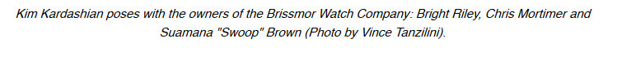

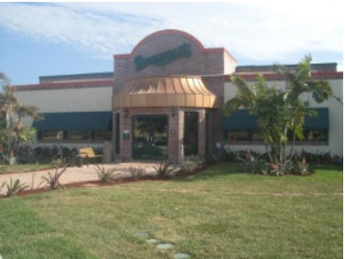Fullscreen capture 692015 94734 AM3erewqwB. A failed restaurant franchise

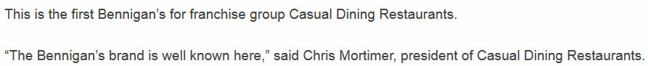

How long did it last? **FOUR MONTHS Officially**



**Unofficially, without any corporate support, the Bahamian franchise died completely within three years and a half years.**

C. Launch of an entirely new third political party in a traditional two-party political system

As the Deputy Leader of the newly formed Democratic National Alliance, Mr. Mortimer poured great resources into preparing for the 2012 Bahamian General Election.

Results:

**ZERO DNA Candidate were elected to office**

Mr. Mortimer is currently preparing for the next general election in 2017

**Summary**

When considering the lack of re-investment done by Galleria Cinemas, only big ticket items like structural changes, projectors and screens replacements have been discussed. At a fundamental level, however Galleria Management has proven to be averse to change.

Basic Cinema business practices prevalent in modern cinemas aren’t being followed. Things like online ticket purchases or ticket kiosks will be new to the Bahamas when Showcase launches.

Galleria Cinemas has relied on its monopoly status to insulate it from needed innovations. With limited entertainment options, Bahamians have been forced to endure substandard theater conditions.

**The Showcase with IMAX will change that.**